Application Deployment guide

Contents

1 Introduction 2

1.1 Purpose 2

2 Components 2

2.1 EDS 2

2.1.1 EDS war creation in DMS 2

2.1.2 Database Tables Required : 3

2.2 FDM Artifacts 4

2.2.1 DMS Class and WorkFlow Subscription Details 4

2.2.2 CE Component 4

2.2.3 Entry Template for DMS class 4

2.2.4 Search Template for DMS 5

2.3 PCC-Configuration 5

2.3.1 ComponentName : 5

2.3.2 Update Server details in below property file 9

2.3.3 In-basket Details. 9

2.3.4 Work Queues 9

2.3.5 Roles 11

2.3.6 In-baskets 12

2.4 Security Proxy 12

2.5 Workflow Subscription 16

2.6 CE Properties 24

2.7 Desktop Creation 25

# Introduction

## Purpose

The purpose of this document is to provide instructions for DMS build deployment into FileNet environment.

# Components

## EDS

### EDS war creation in DMS

As EDS War already deployed please add below .class files in path and property file.

1. Modified “ObjectTypes.json” file included below code

{"symbolicName": "Edelwesis"},

{"symbolicName": "DMS"},

{"symbolicName": "EdelweissDMS.Workflow.Dispatch"},

{"symbolicName": "EdelweissDMS.Workflow.Archival"}

2.Modified Util.properties file with included below code.

DMS_CLSSES = DMS, EdelweissDMS.Workflow.Dispatch,EdelweissDMS.Workflow.Archival

WorkFlowMandartoryClasses = EdelweissDMS.Workflow.Dispatch,EdelweissDMS.Workflow.Archival

3. Included below class names in EDS.

1. EDS_JSONPropCreat
2. SbuDTO
3. LobDTO
4. ProductDTO
5. RecordMasterDTO
6. ReadProperty

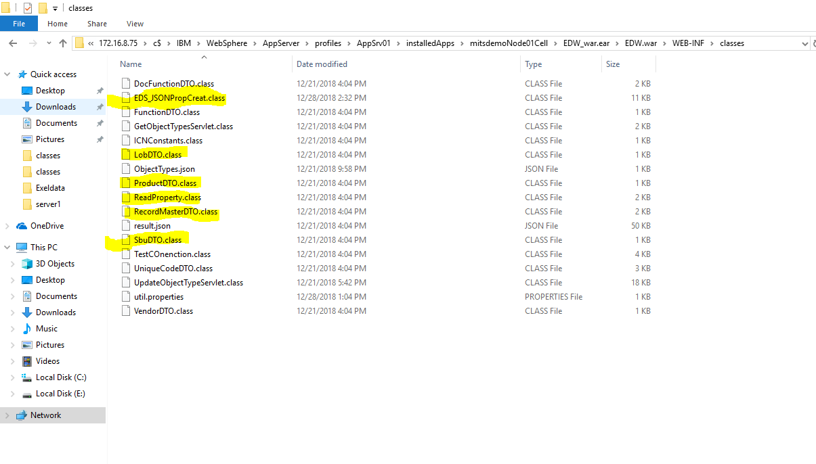

### Database Tables Required :

1. SBU
2. LOB
3. PRODUCT
4. RECORDMASTER
5. ENTITY

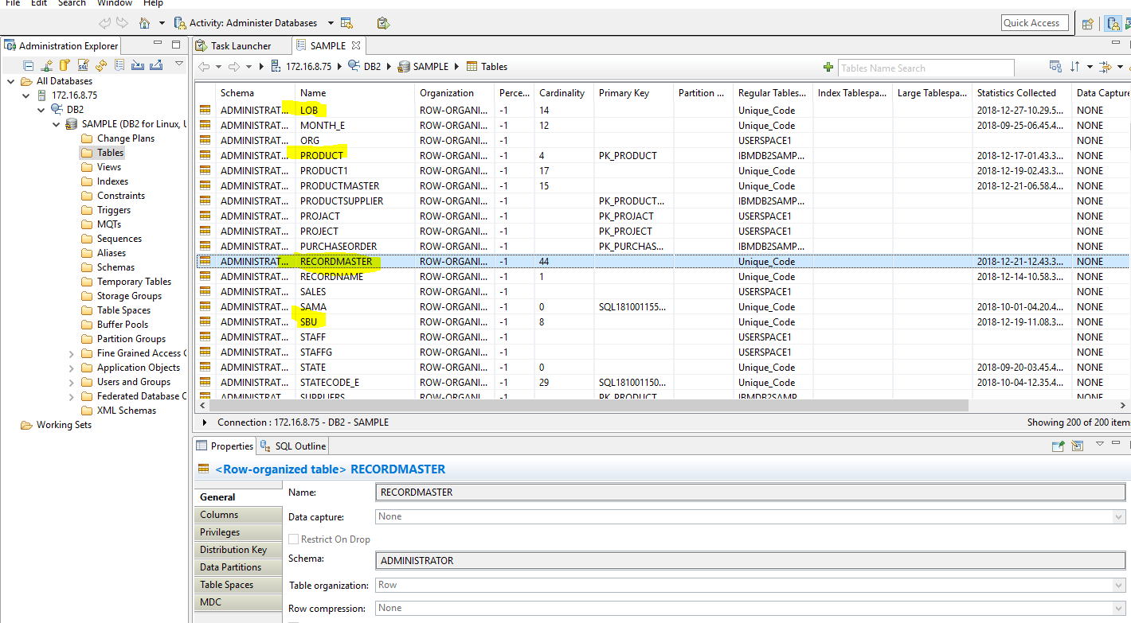

## FDM Artifacts

### DMS Class and WorkFlow Subscription Details

1.Created Document class name with “DMS” in FNOS and Workflow name with ‘EdelweissDMS’ with properties

2. Created workflow subscription with “create event” action.

### CE Component

1. Component to update dispatch and archival date to workflow properties.(UpdateArchivalDateinContentEngine).

2. Component for add content to existing document if Product and Client ID when same(Updateddocumentproperties).

3. To maintain versions(UpdateWorkflowComponent).

4. Security to add document and folder.

### Entry Template for DMS class

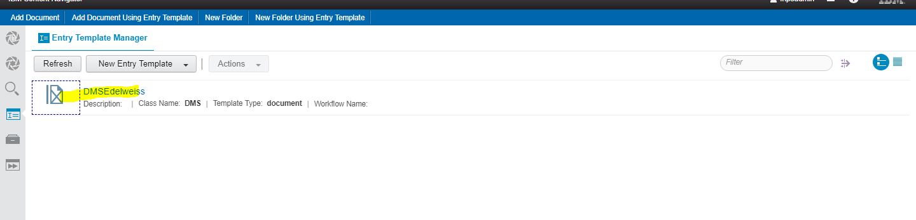

### Search Template for DMS

Click on Search feature and create new search by adding below fields.

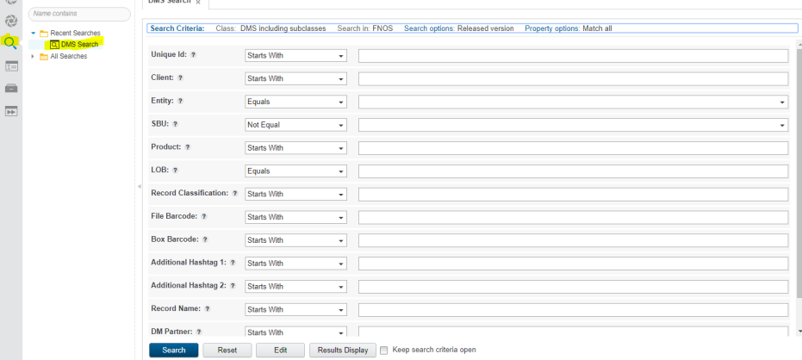

Click on results disply button and add below parameters.

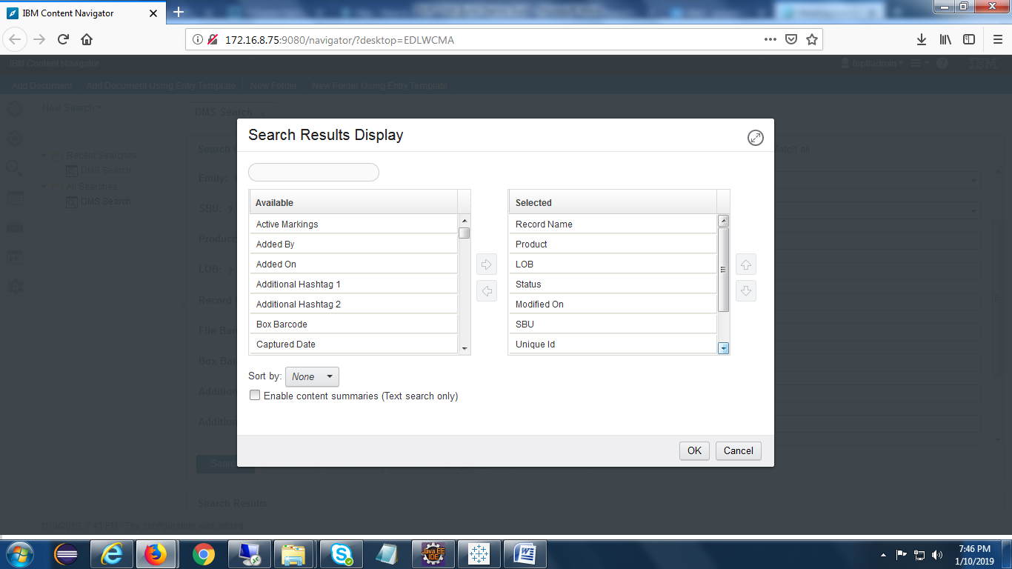

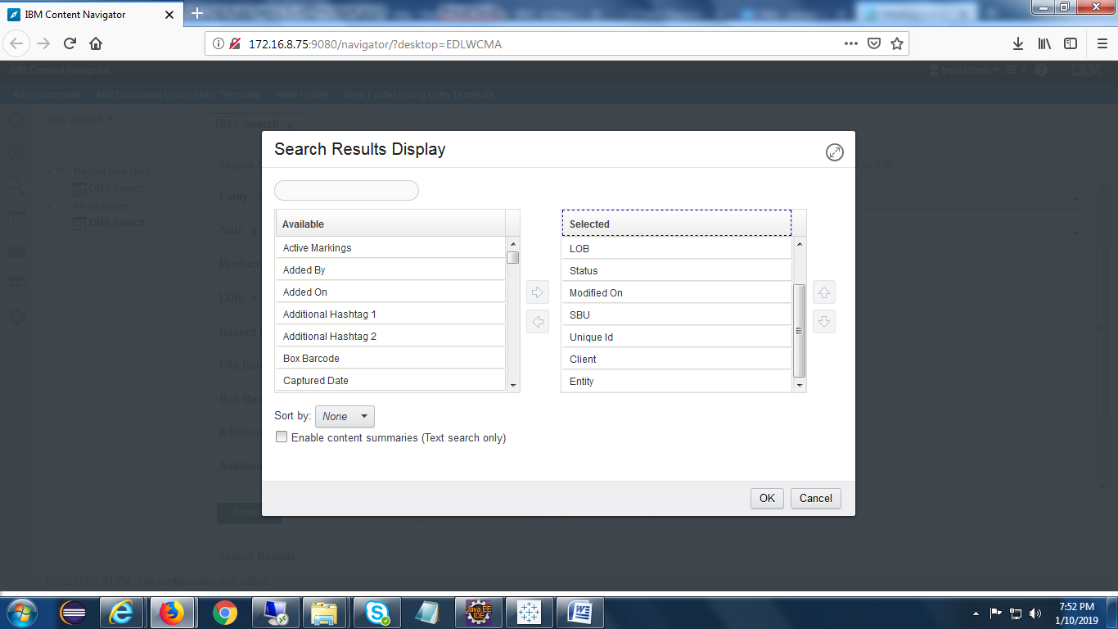

## PCC-Configuration

In “work Queue” create below two queues.

1. Archiving
2. ScanningQA.

### ComponentName :

Create below component :-

* Workflowupdatecomponent.

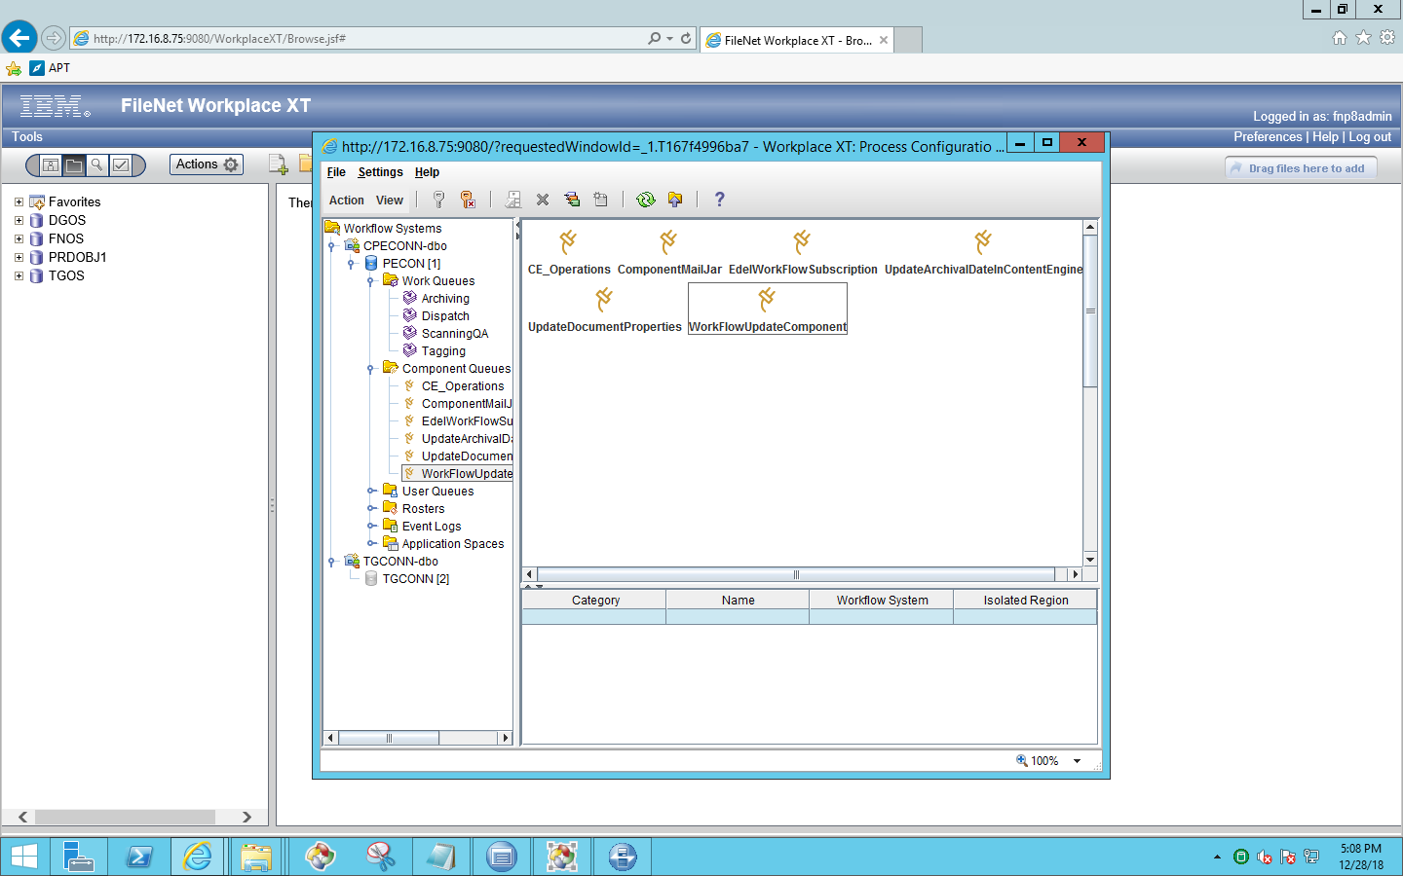

Click on adopter , then we will find below screen

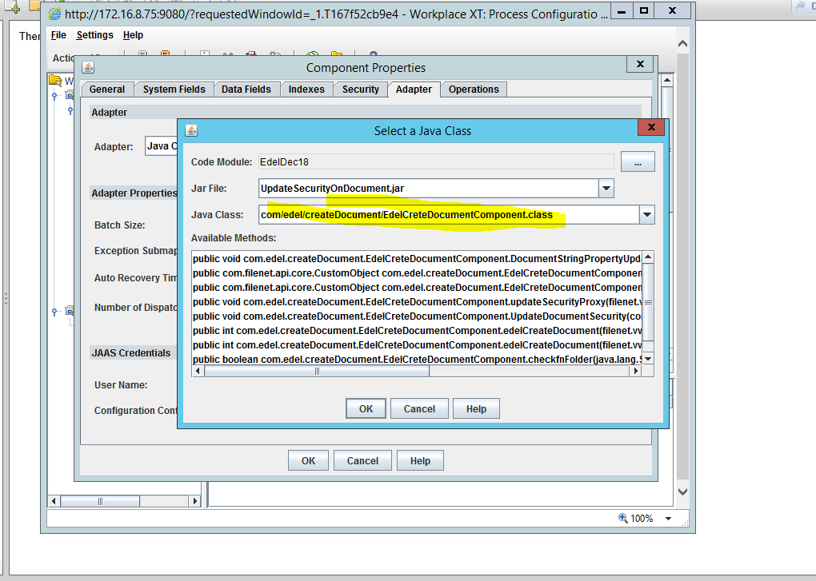

Click on properties , then we will find below screen

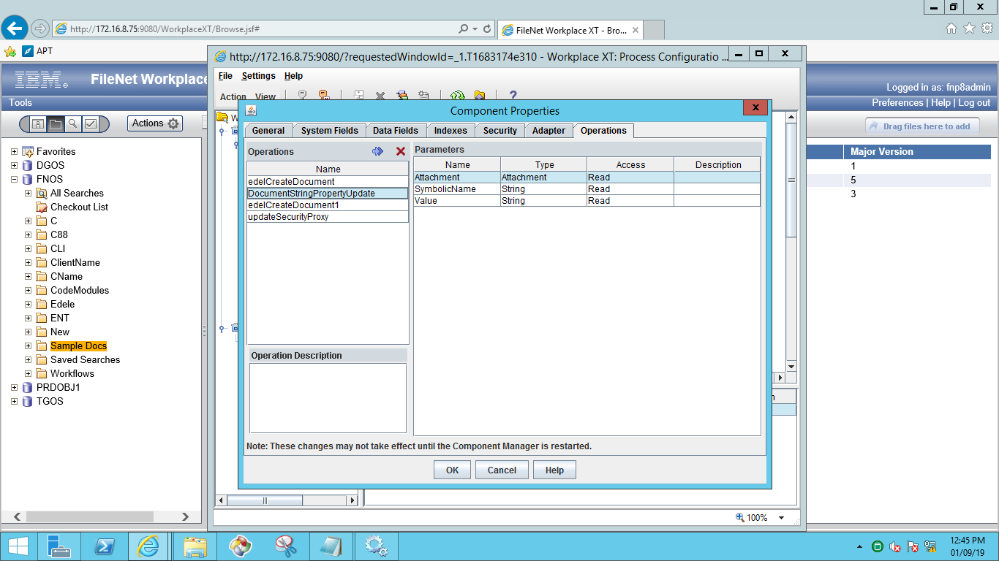

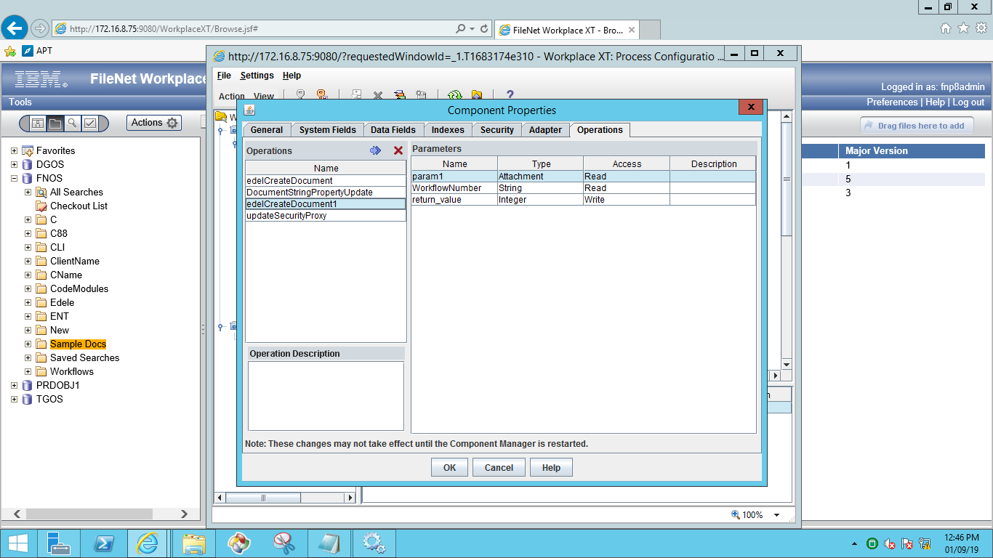

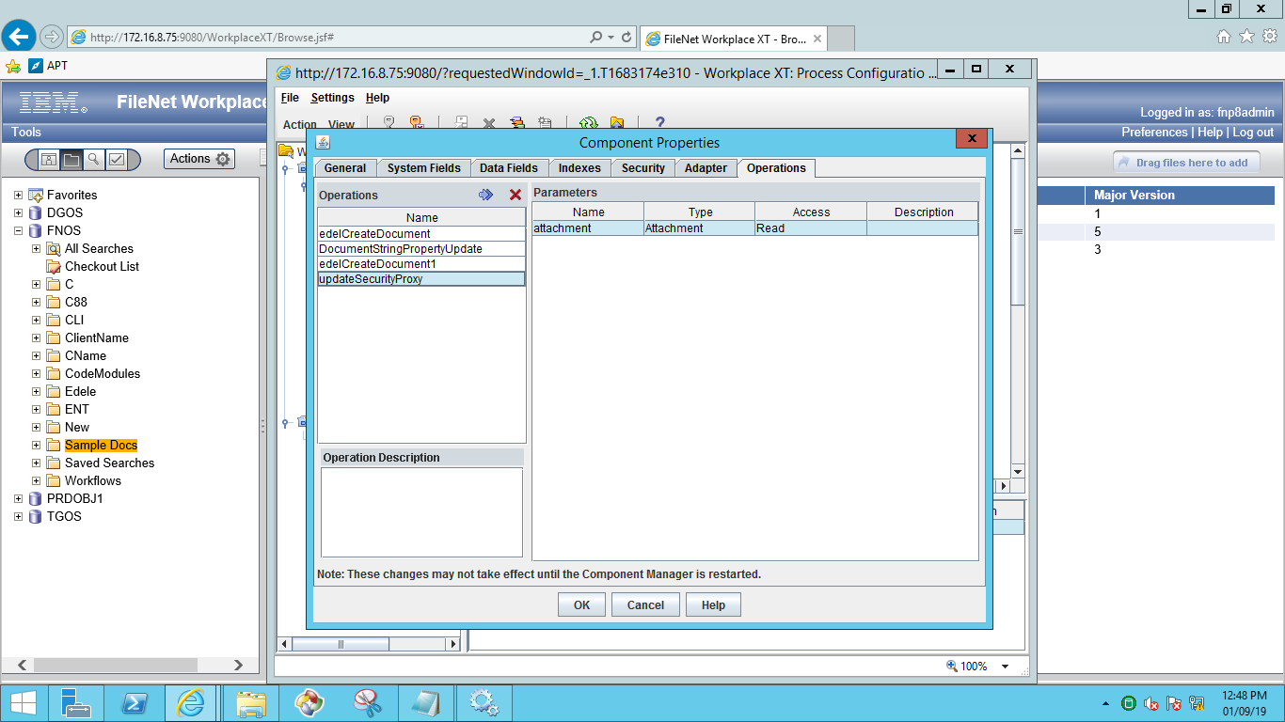

* UpdateArchivalDateInContentEngine

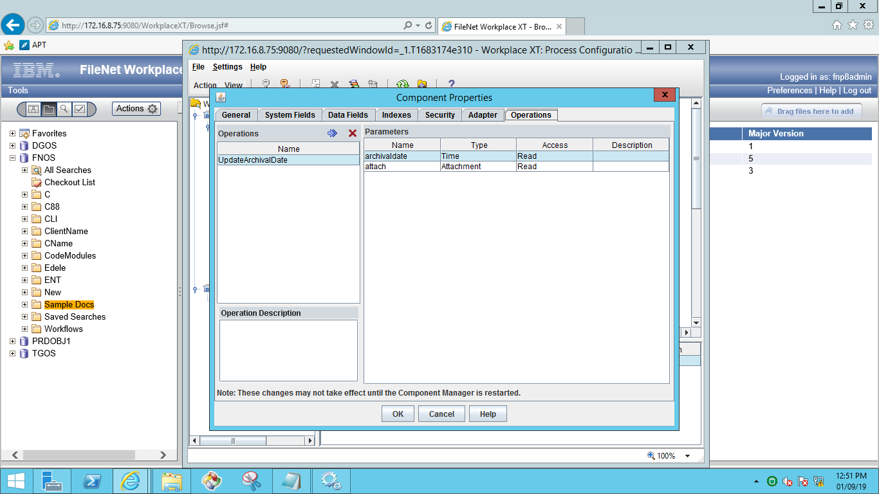

* UpdateDocumentProperties

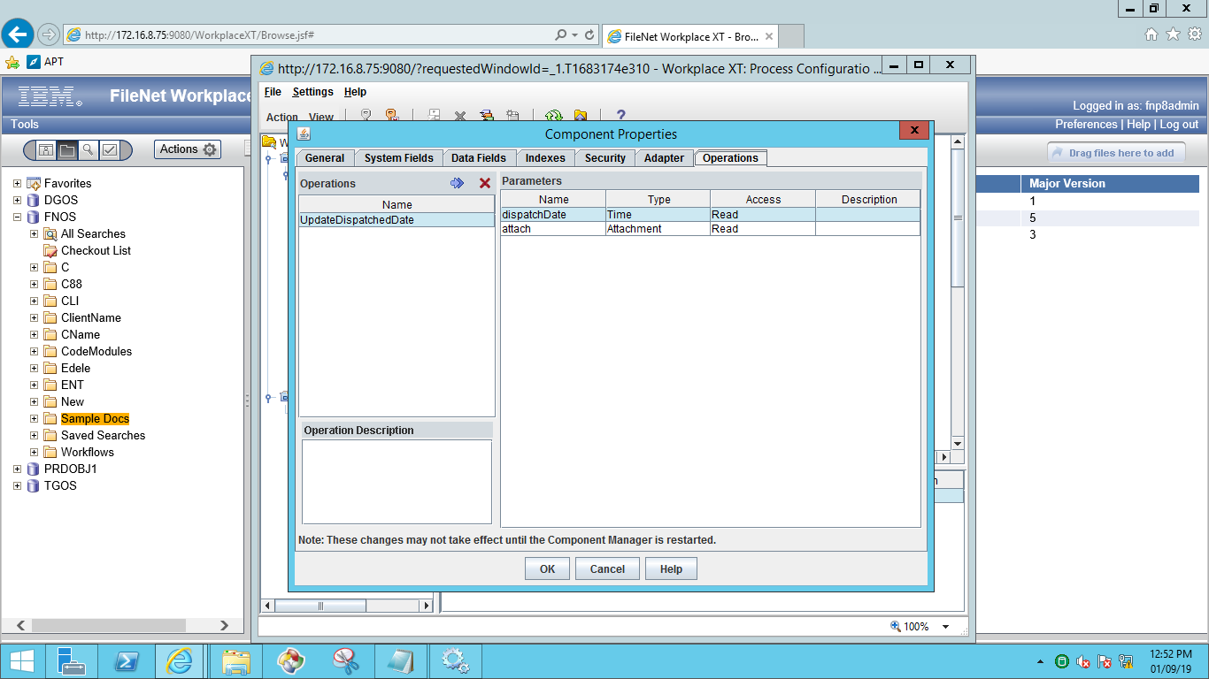

### Update Server details in below property file

Property File Path: C:\Edel\CreateDocument.properties

### In-basket Details.

1. Created In-basket’s for different roles.
   * 1. Processing
     2. Archival
2. Processing step used In-basket ‘Processing’ and “Scanning QA” Queue used.
3. Dispatch step used In-basket ’Archival’ and “Archiving” Queue used.
4. Archive step used In-basket ’Archival’ and “Archiving” Queue used.

**Note**: Same In-basket and Same Queue used for above two –steps.

### Work Queues

Create below Work queues

* Archiving
* ScanningQA

**Procedure to create work queues:**

Open WorkplaceXT and go to process configuration console and select **work queue** to create new one.

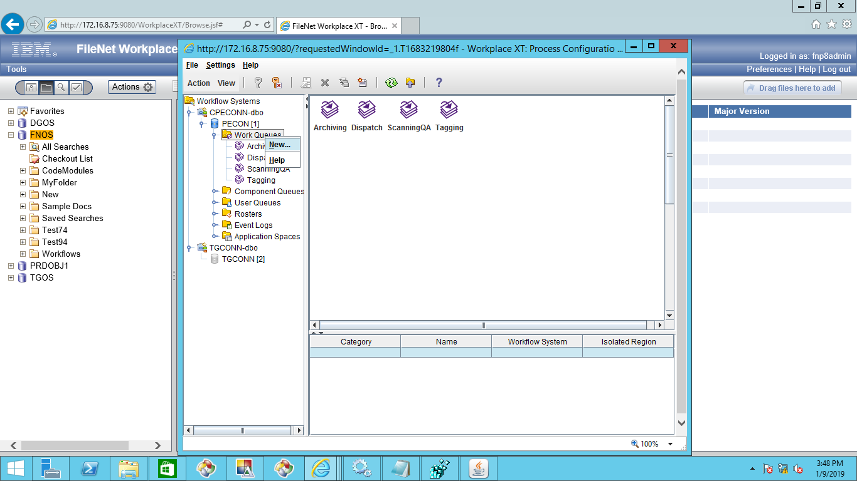

After creation of work queue ,go to data fields and add required fields as below,

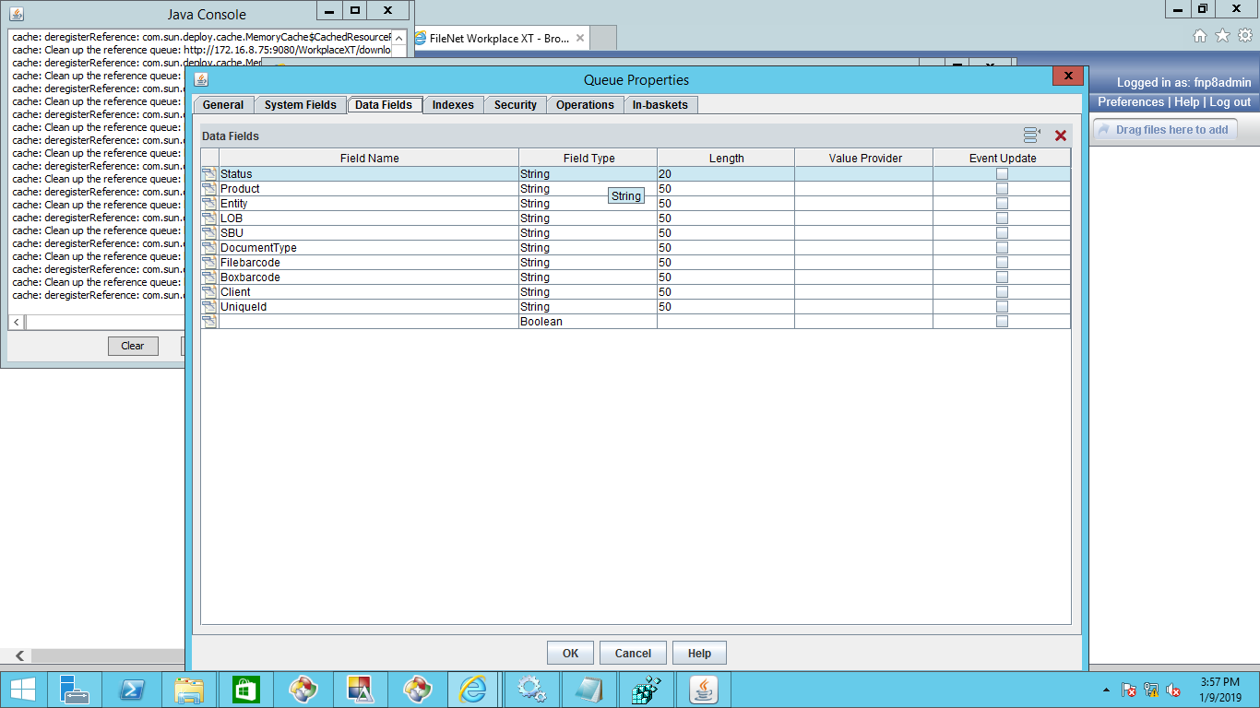

After adding the data fields click on inbasket and create inbasket and add the data fields as shown in below screen.

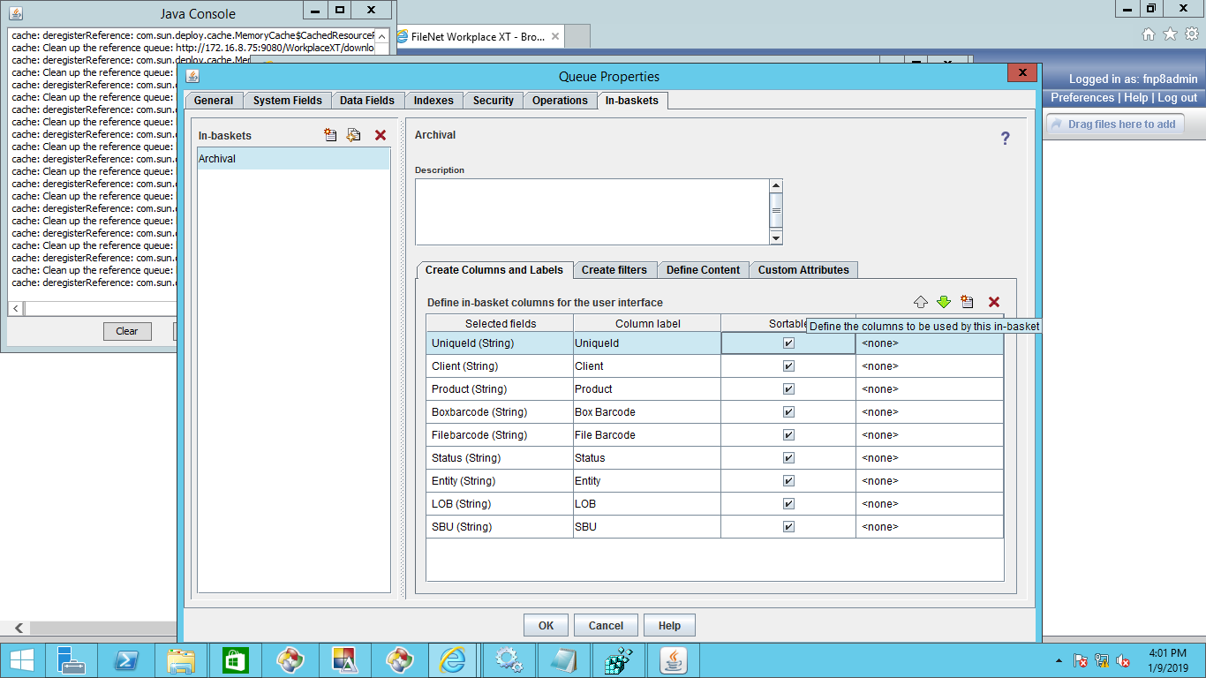

### Roles

Below are the roles

* Archival
* Processing

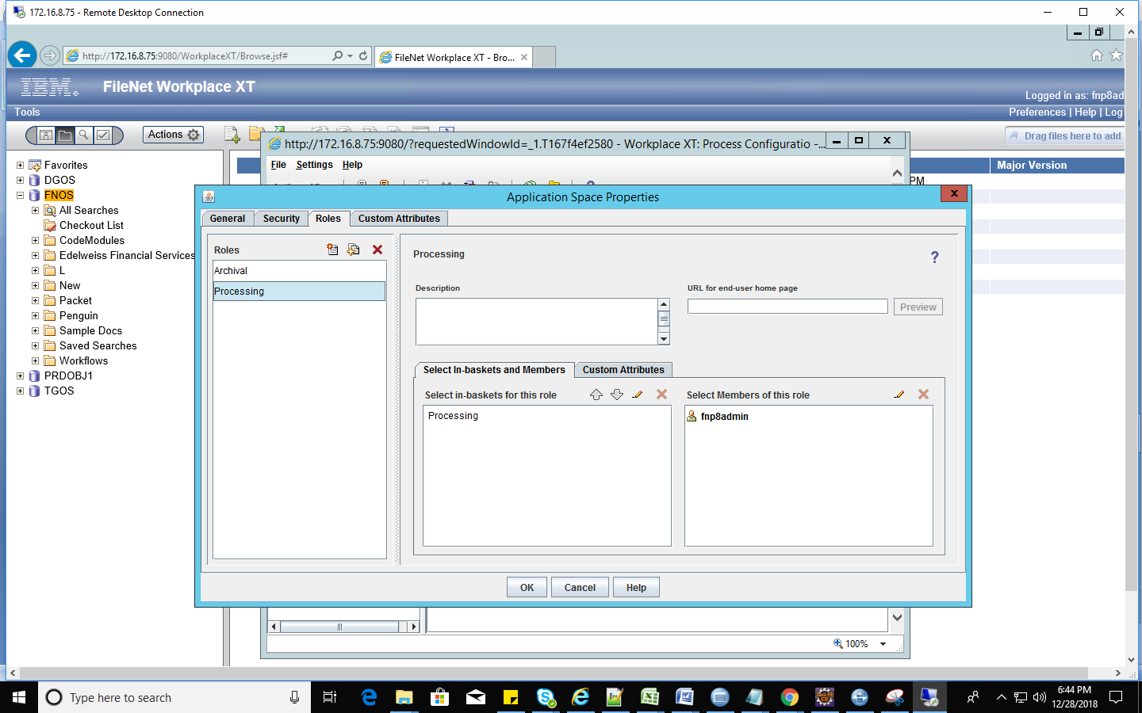

### In-baskets

Below are the In-baskets for roles.

* Processing
* Archival

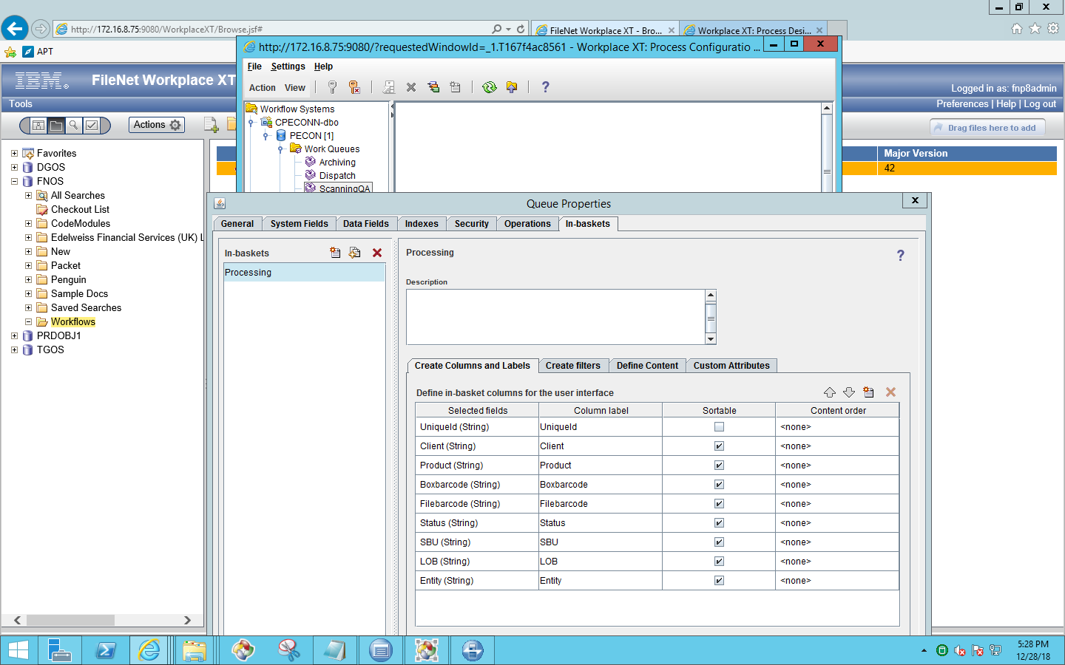

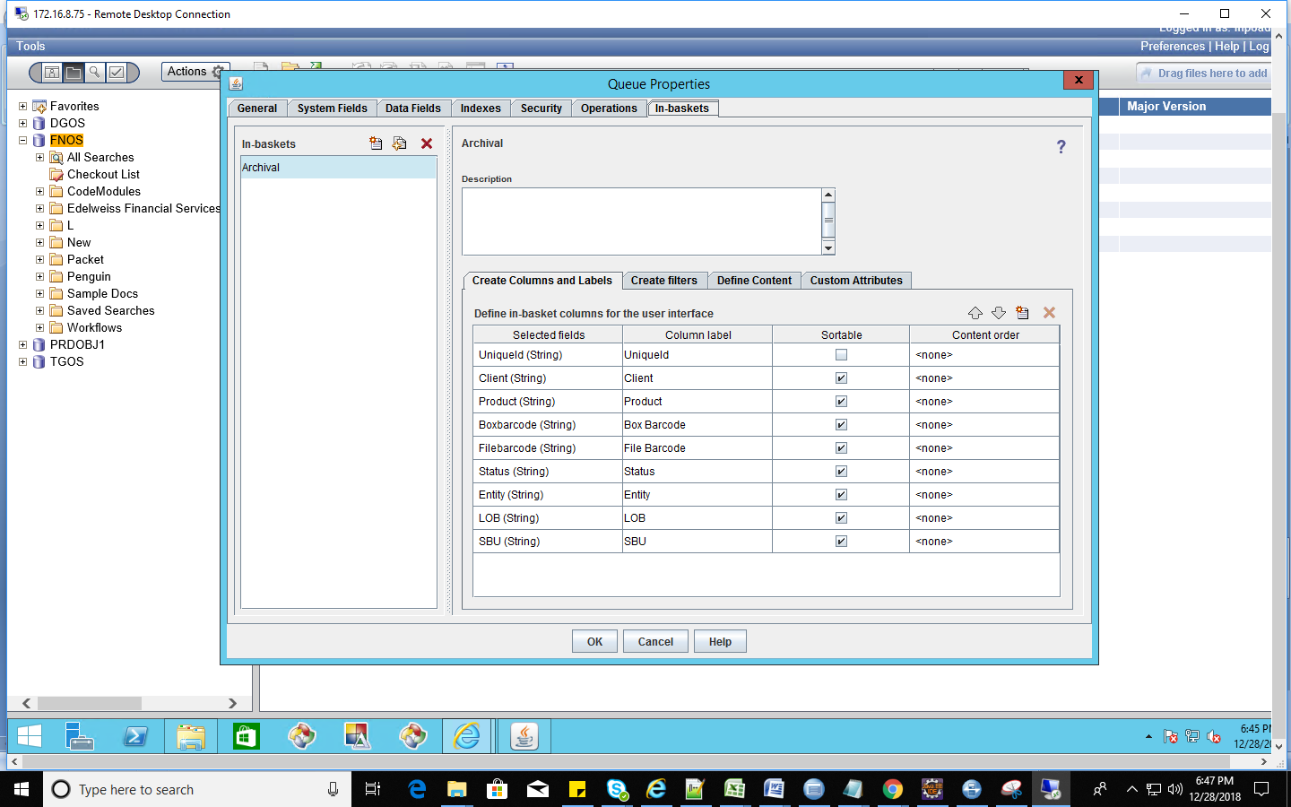

## Security Proxy

Create Proxy Class in Customobject

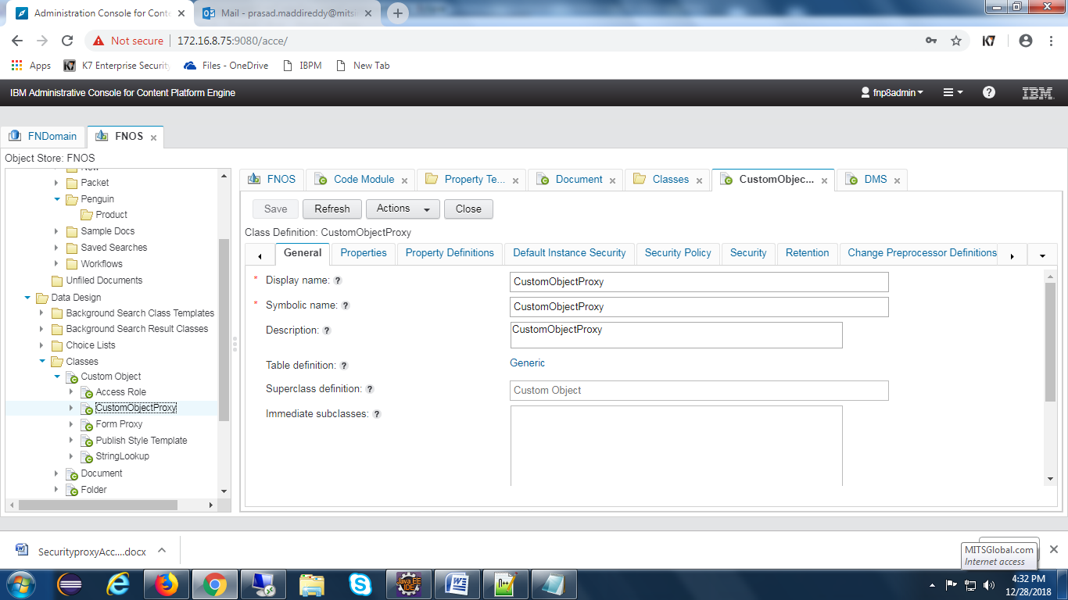

Create proxy property

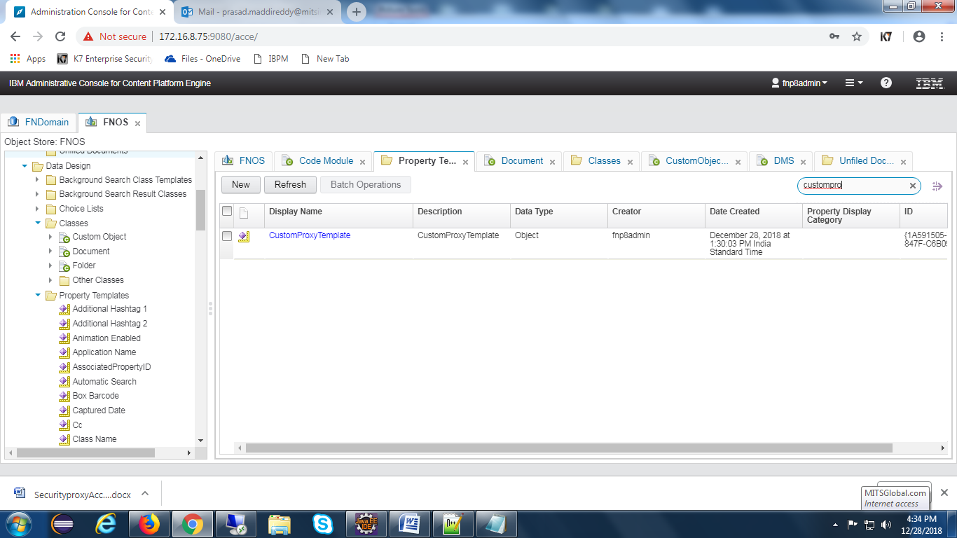

Add property to folder class

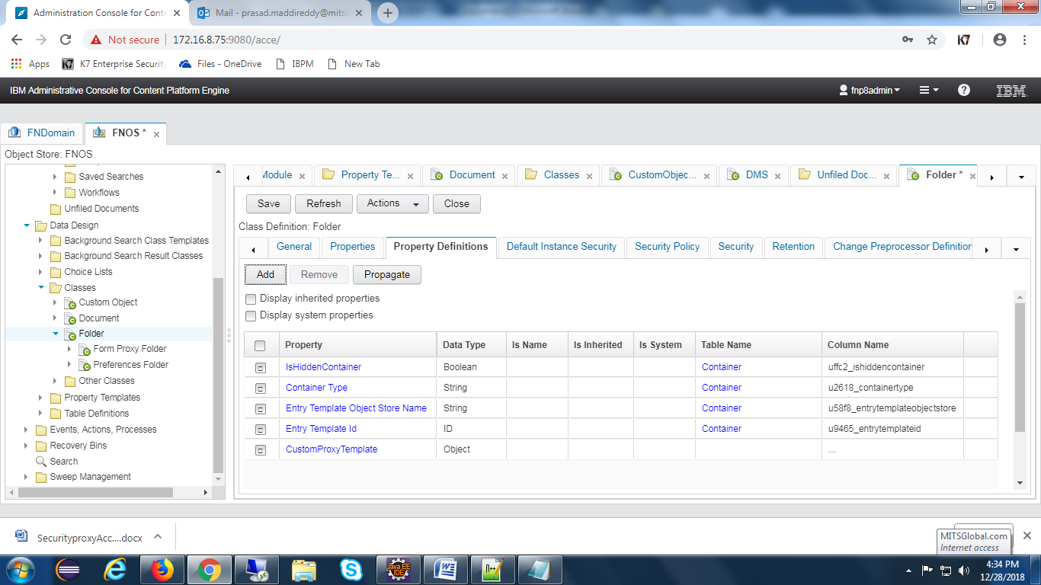

Set class type as CustomObjectProxy to the property

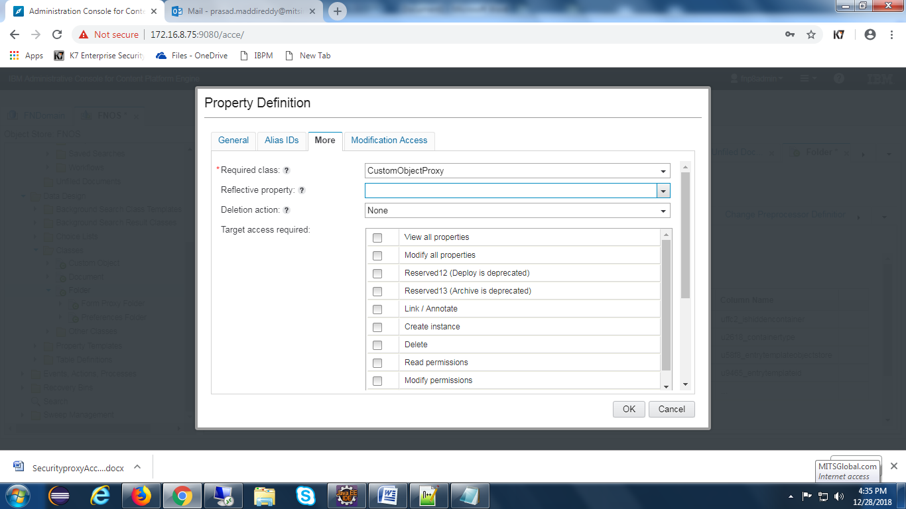

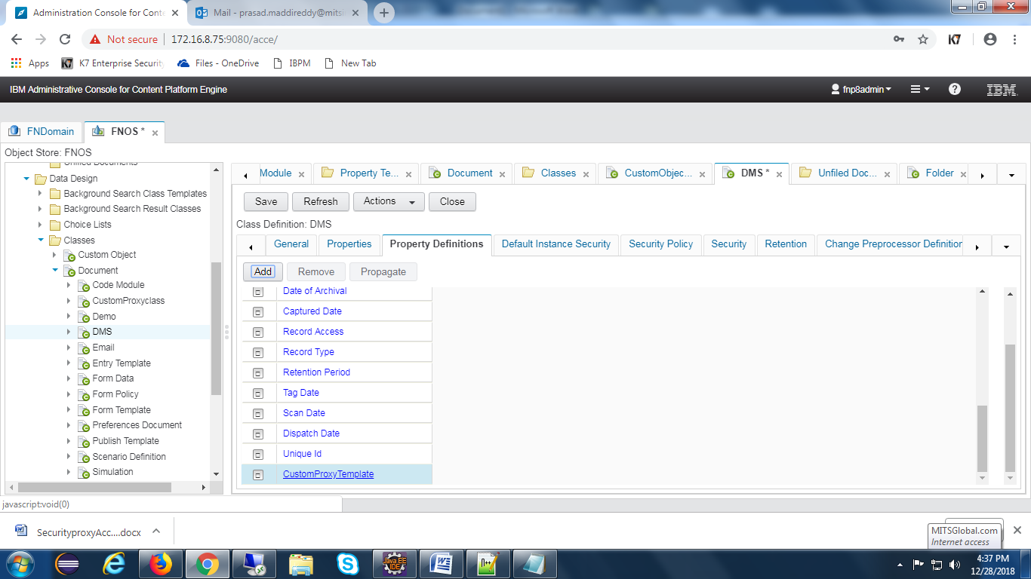

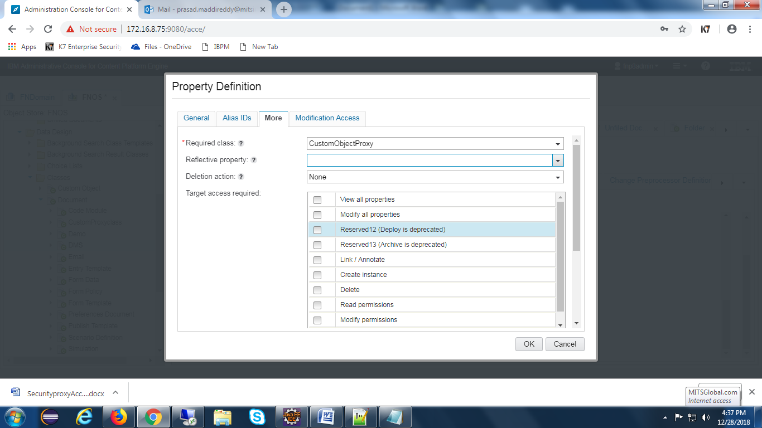

Create two proxies for document and folders

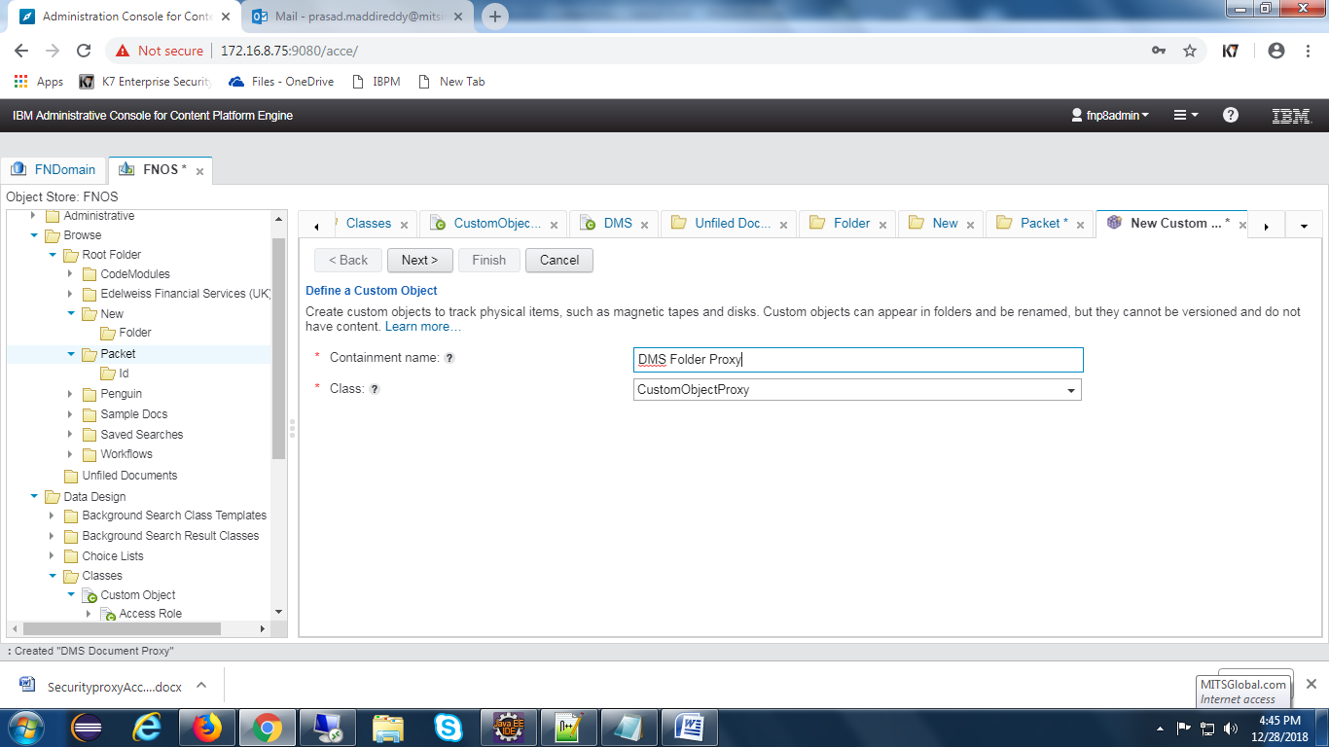

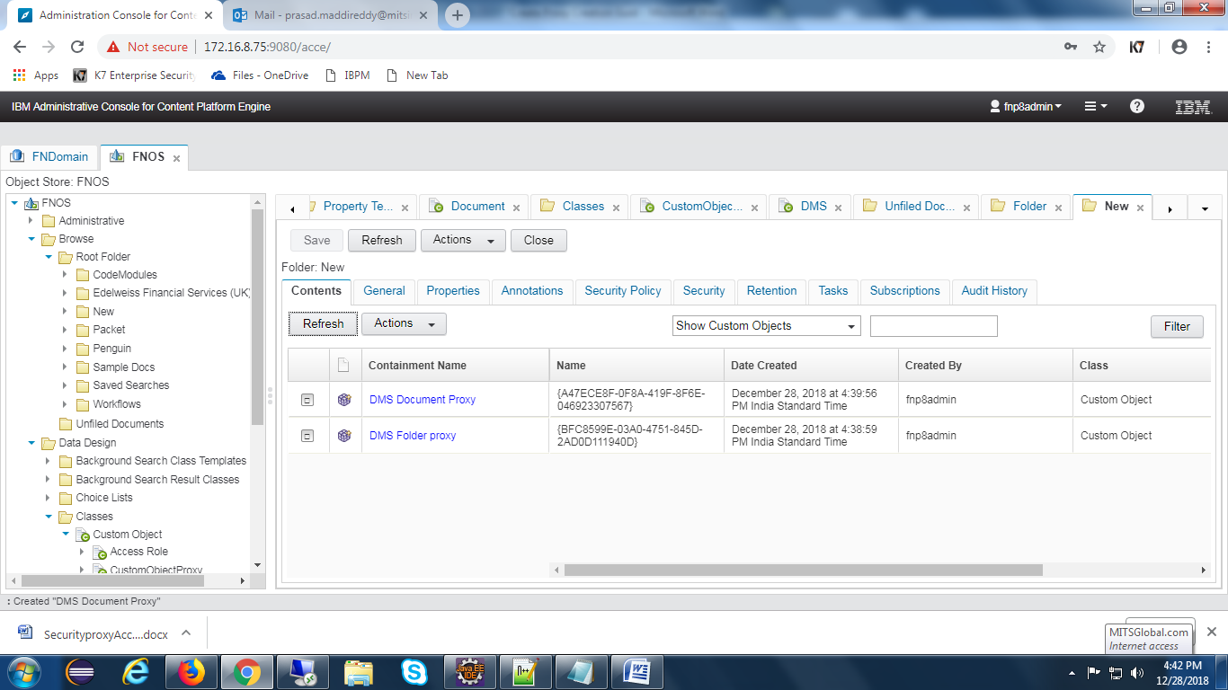

## Workflow Subscription

**Create Event action:-**

Open acce and select event actions tab to create event action.

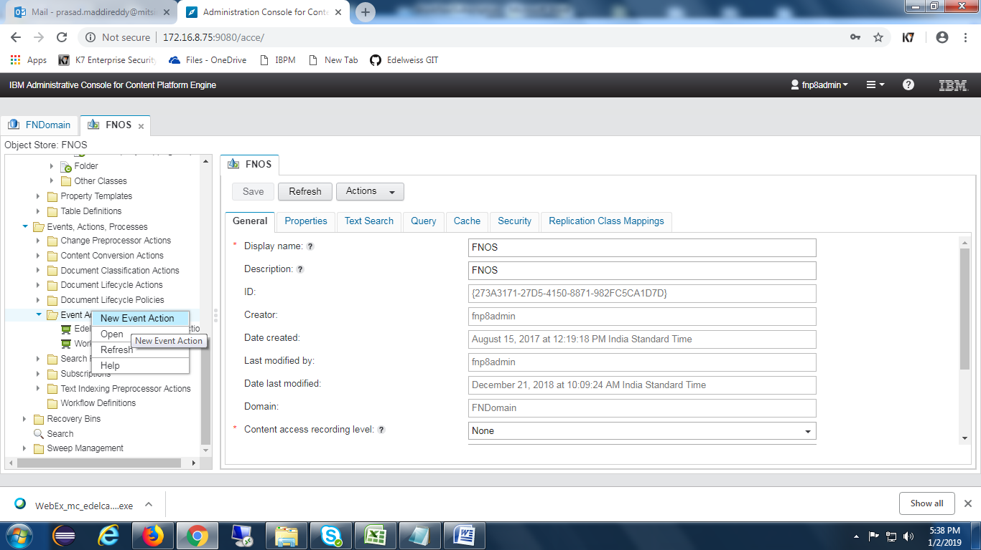

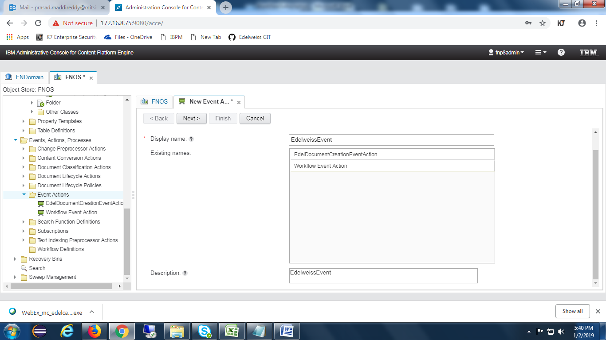

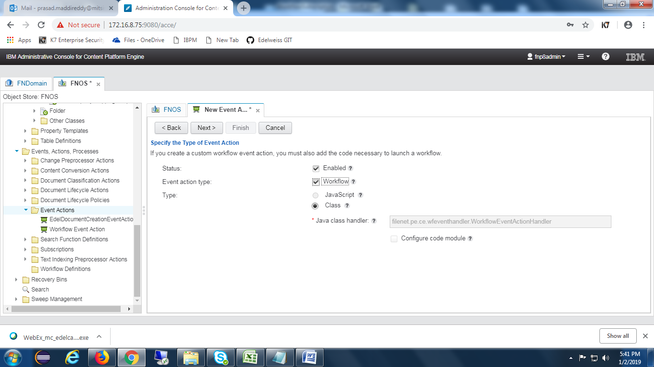

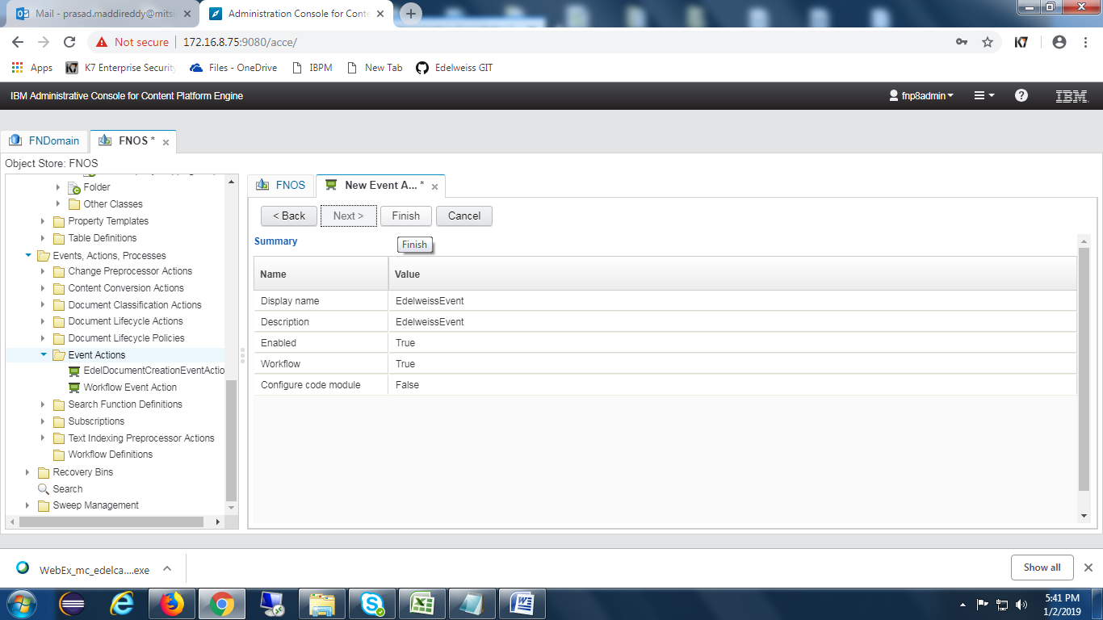

**Create Subscription:-**

Select the required class to create subscription. Once selecting the class , choose subscription button as shown in the below screen.

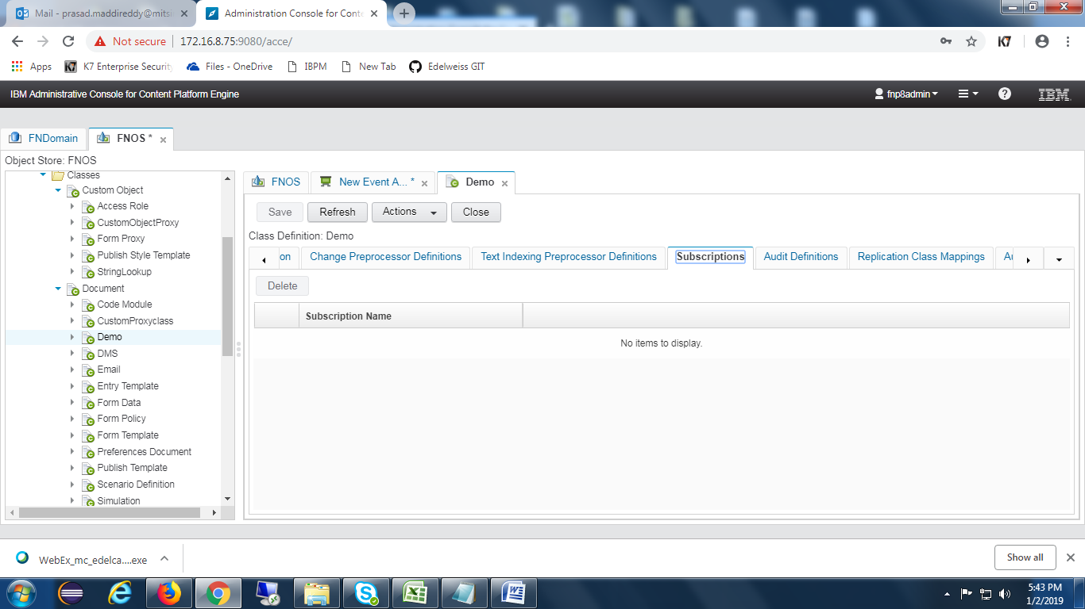

Click on **Actions** and select New subscription as below.

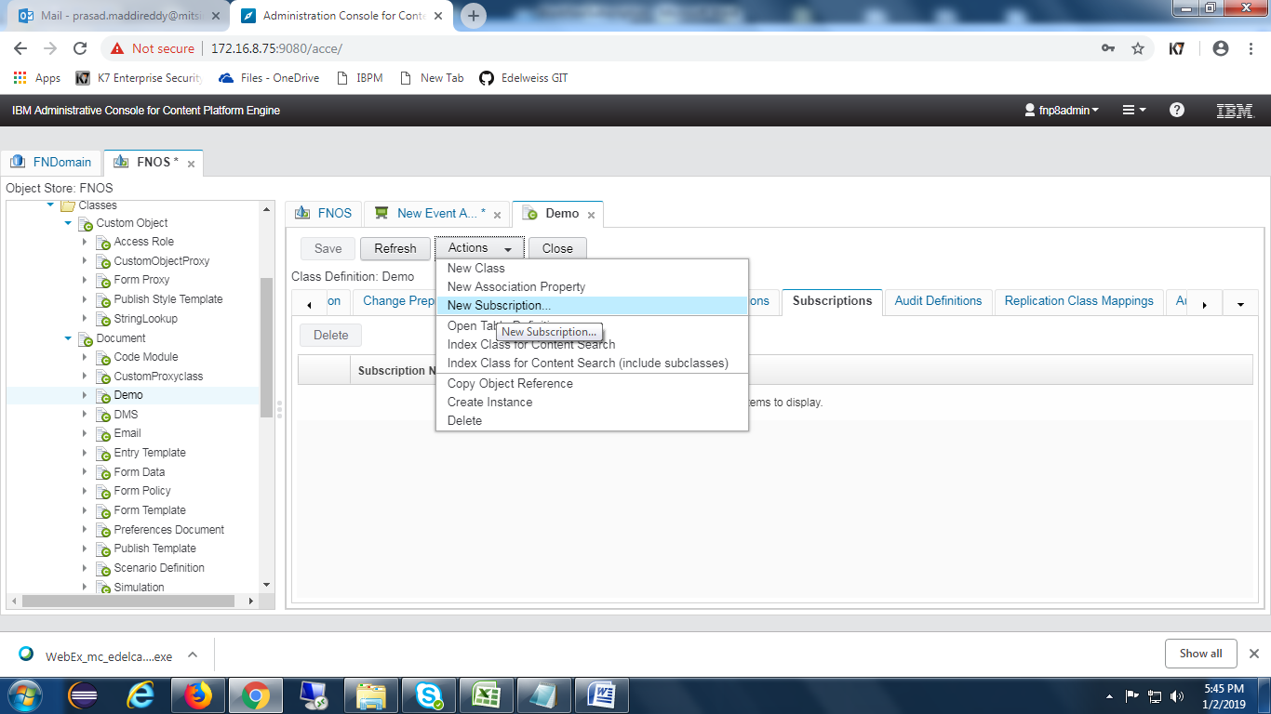

Give name for the subscription.

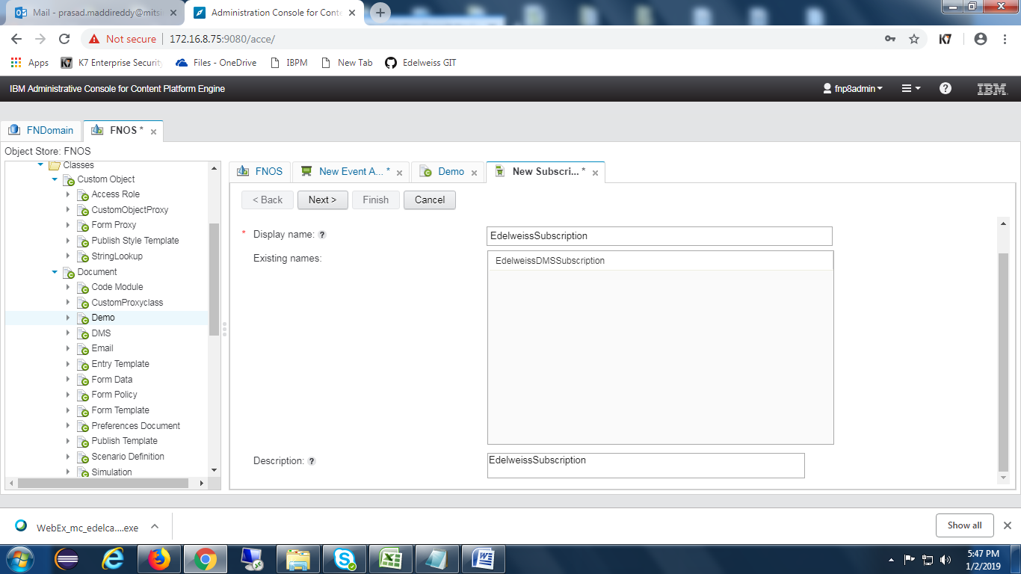

Select **Create a workflow subscription** checkbox as shown in the below screen.

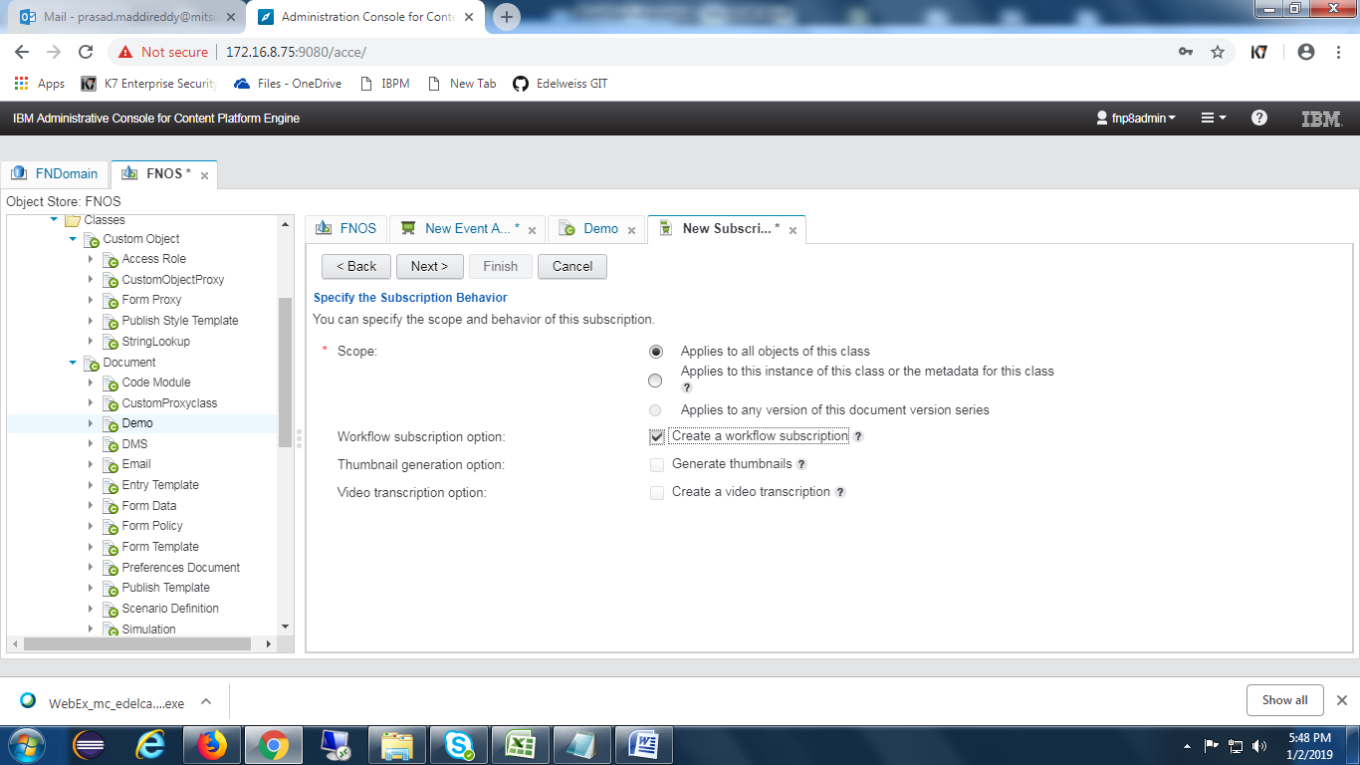

Choose appropriate **Event(Creation Event)**

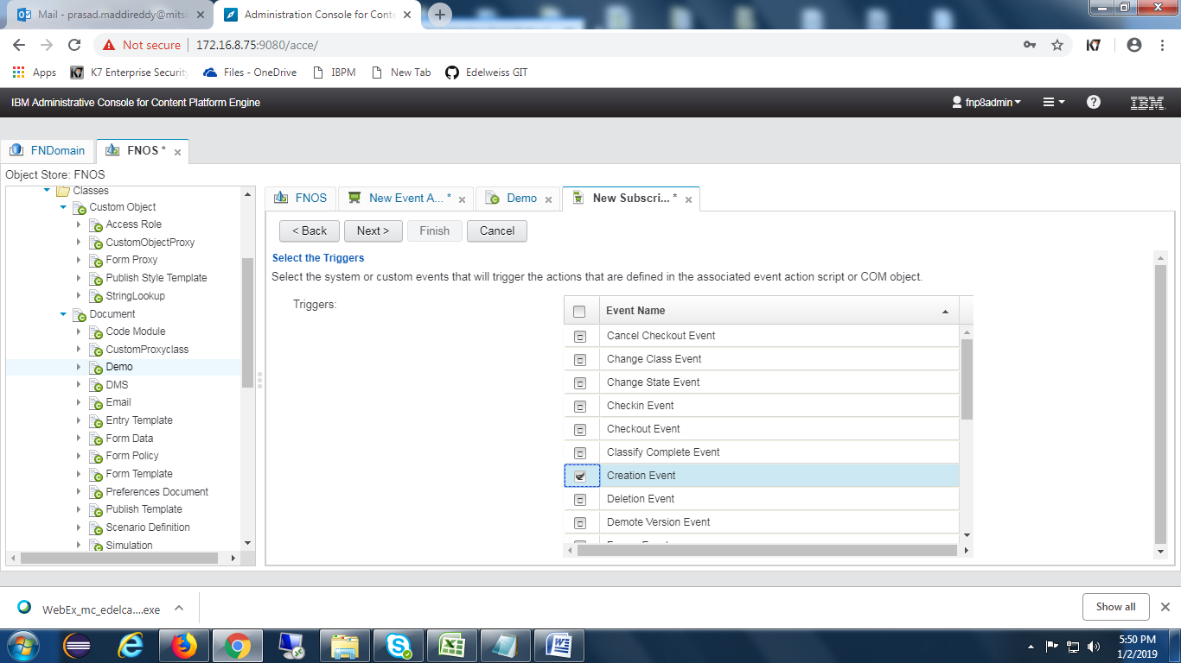

Choose the **event action** which was created earlier.

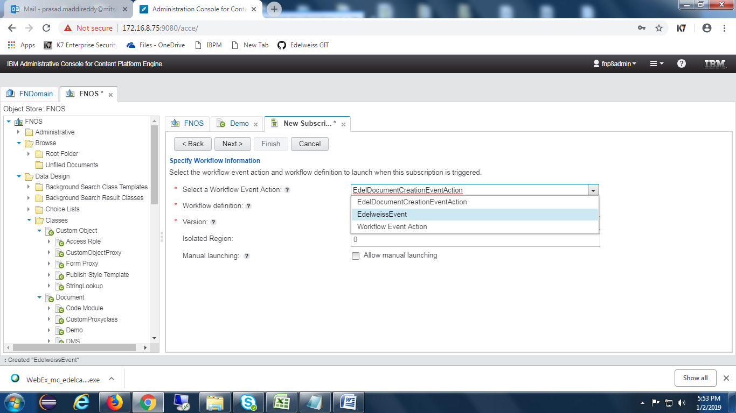

Choose the **Workflow** shown in the drop down.

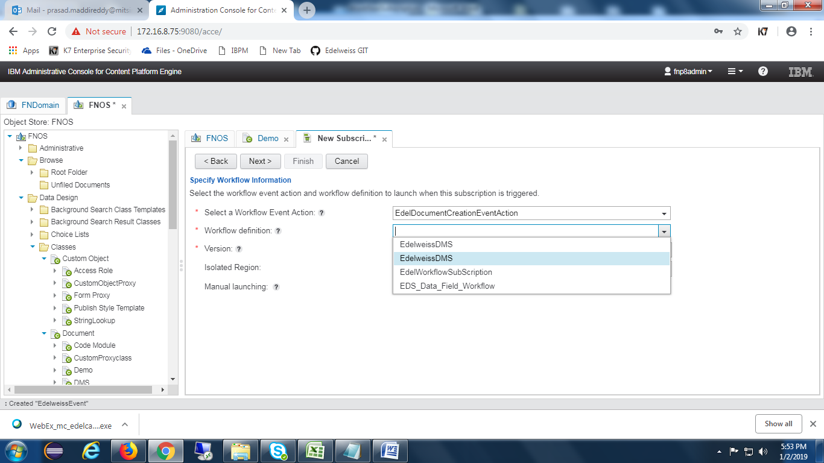

Map Workflow properties with the CE properties as below

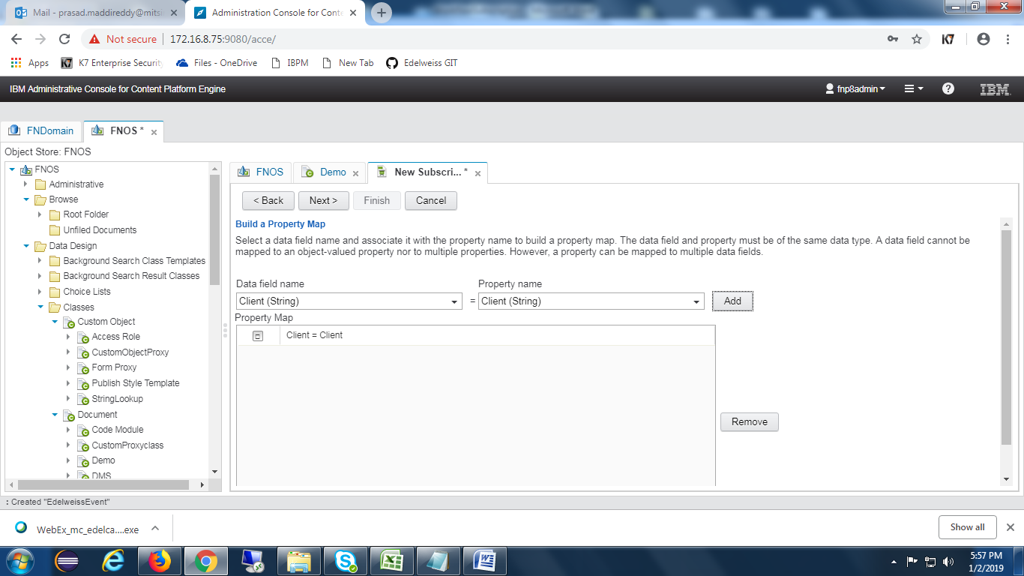

Click on **Next** button as shown in the below screen.

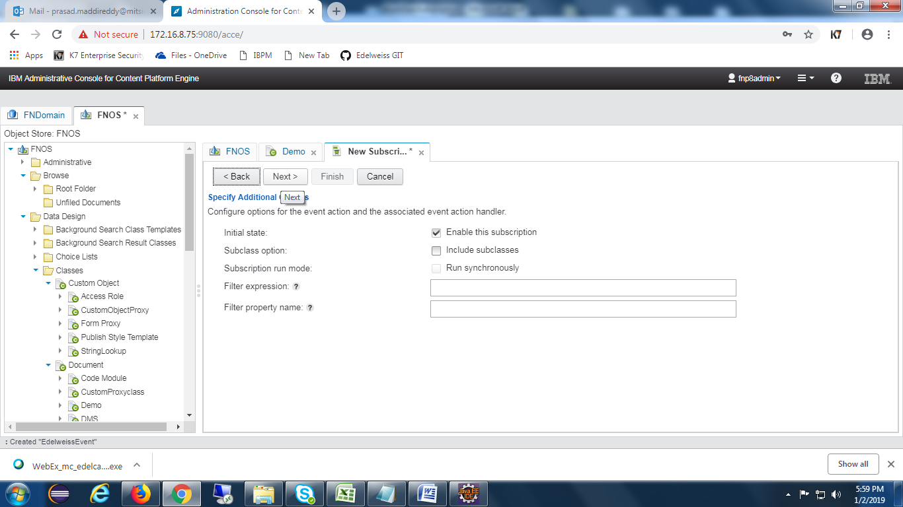

Press on **Finish** button as well.

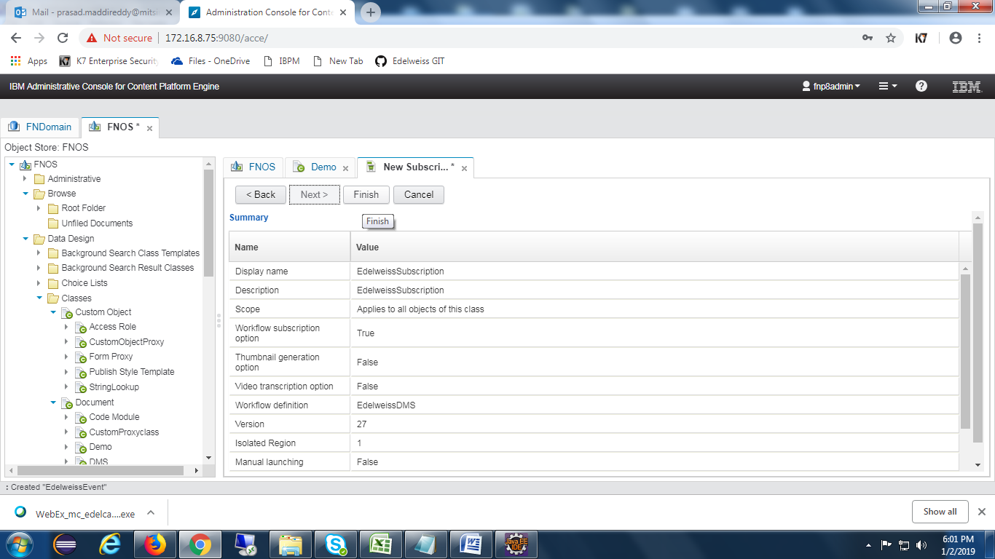

## CE Properties

Below are the symbolic names of the property templates.

I. AdditionalHashtag1(String)

II. AdditionalHashtag2(String)

III. BoxBarcode(String)

IV. CapturedDate(Date Time)

V. Client(String)

VI .CustomProxyTemplate(Object)

VII. DateofArchival(Date Time)

VIII. DispatchDate(Date Time)

IX. DMPartner(String)

X. DocumentType(String)

XI. Entity(String)

XII. FileBarcode(String)

XIII. isWorkflowLaunched(Boolean)

XIV. LOB(String)

XV. Product(String)

XVI. RecordAccess(String)

XVII. RecordClassification(String)

XVIII. RecordName(String)

XIX. RecordType(String)

XX. RetentionPeriod(String)

XXI. SBU(String)

XXII. ScanDate(Date Time)

XXIII. Stage(String)

XXIV. Status(String)

XXV. TagDate(Date Time)

XXVI. UniqueId(String)

## Desktop Creation

Open navigator and select **Open administration view** feature. Select **new desktop** button and it will show below screen.

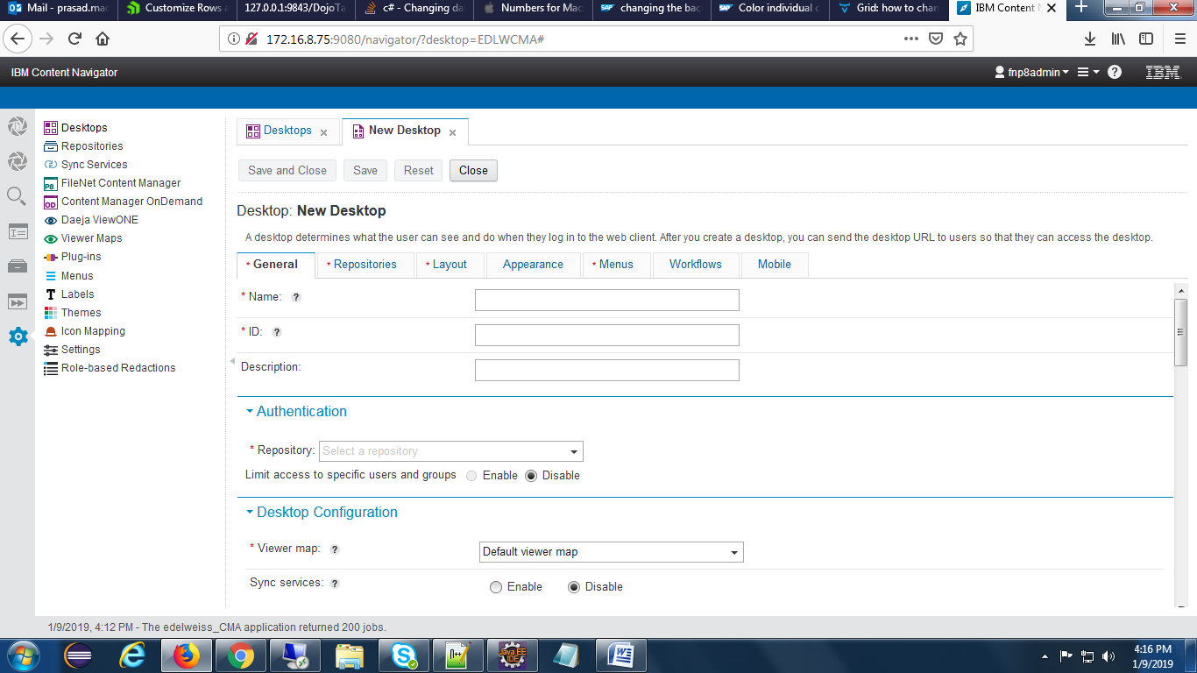

Provide desktop Name and Id and Description and select appropriate repository in the drop down of repository.

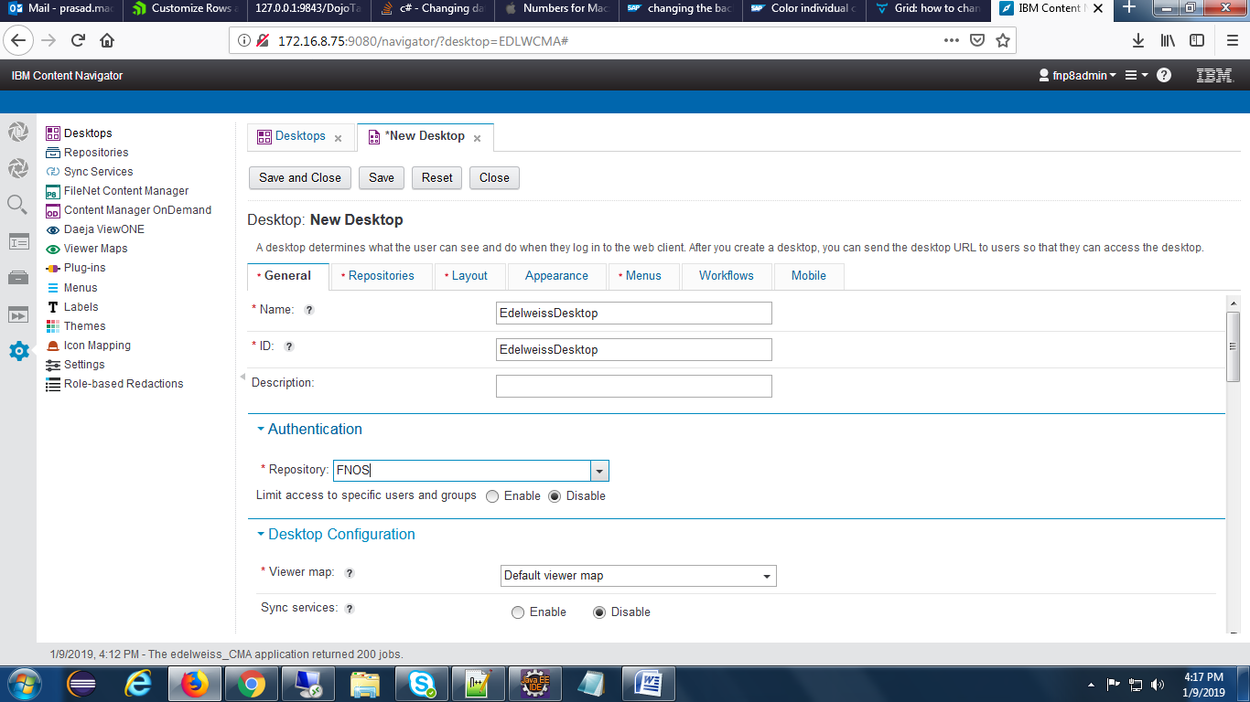

select repositories tab and choose the repository as below.

